Shabbos Stories for
Parshas nasso 5783
Volume 14, Issue 38 – 14 Sivan 5783/June 3, 2023
Printed L’illuy nishmas Nechama bas R’ Noach, a”h
For a free subscription, please forward your request to keren18@juno.com
Past emails can be found on the website – ShabbosStories.com

Being Mesiras Nefesh for Honoring Shabbos

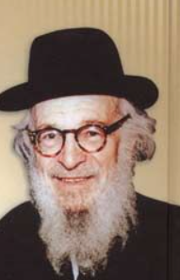
Rav Zaidel Epstein

Rav Zaidel Epstein relates a story of a European Jew who immigrated to America prior to the Holocaust. Making ends meet in Europe was becoming more difficult. As the social climate shifted against the Jew, it became increasingly difficult to earn a living.
The story is about a ben Torah, yeshivah student, who was diligent in his study of Torah and equally G-d-fearing. He married, and Hashem blessed them with a growing family. He earned a meagre living which, even by European standards, was insufficient to feed his family.
The couple decided to leave Europe for America with the hope that their material needs would be met there. They did not take one thing into consideration: In America, Shabbos observance meant Sunday. Shabbos was a regular day of work. He lost track of how many times he was fired on Friday.
His brother, who had arrived earlier and was running a successful knitting factory in the Midwest, invited him to join him there. He would hire him to work with no demands regarding Shabbos. His wife was suspect of her brother-in-law’s offer. She refused to move. They decided that the husband would move alone and send his wages to his wife to support his family.
All went fine for the first few weeks. The man worked all week, and Shabbos was his day of rest. Every worker in the factory showed up for work on Shabbos except for him.

Just Come in and Sit in the Shop and Don’t Work
A short while later, his brother told him that the other workers were complaining that they worked all week, while the boss’s brother stayed home and spent time in the synagogue. His brother asked if he would just come in and sit in the shop – not working – just sit around. At first, he was reluctant to do so, never having been anywhere but his home and shul on Shabbos, but, after all, his brother had been kind to him. What could be so wrong if he just sat around?
All was quiet until, one Shabbos, the machine that held the knitting machine in place came to an untimely end. The foreman asked him if he would just hold the machine in place, in order for the knitting to continue. No Shabbos desecration other than touching/holding the machine which was muktzah (set aside for weekday use and Rabbinically prohibited). In short, once he had done this, he was on the way to complete digression and working on Shabbos. This is the meaning of nimshach, being drawn/sucked into sinful behavior. Subtle acquiescence leads to full blown participation.

******************************************************************

The Chafetz Chaim heard that in Radin an observant bookseller was selling inappropriate material, such as books and novels by secular authors who were under the influence of the Haskalah/Enlightenment movement. (Such reading material can have a devastating effect on one unschooled in Torah outlook.) The sage asked that the man appear before him. He asked him to bring all the questionable reading material to his home.
The man came and brought the books. The Chafetz Chaim immediately burned each one. (I am certain that he first paid for them.) He said, “I will not allow such reading material to be disseminated in Radin!”
“But, Rebbe, a man has to earn a living. This is what sells. Should I allow my family to starve?” the bookseller countered.

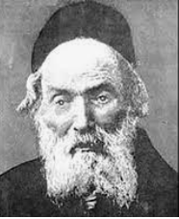

“Do not fret,” the Chafetz Chaim responded. “I will find suitable work for you.” A few days later, the Chafetz Chaim summoned the man to his home with a job proposal, “One of the workers at the local church died suddenly. His job was to ring the bell in the church on Sundays to remind the people to come to the service.” It was a strenuous task, but the man would earn a living.
“Rebbe, I am an observant, G-d-fearing Jew. How can I summon gentiles to church?”
The Chafetz Chaim replied, “Better that you summon gentiles to church, than you cause the minds of Jews who do not know better to be poisoned.”

Reprinted from the Parshas Bamidbar 5783 edition of Rabbi A.L. Scheinbaum’s Peninim on the Torah.

Story #1327
A Happy Surprise in
the Moslem Quarter
of Jerusalem
From the desk of Yerachmiel Tilles
editor@ascentofsafed.com

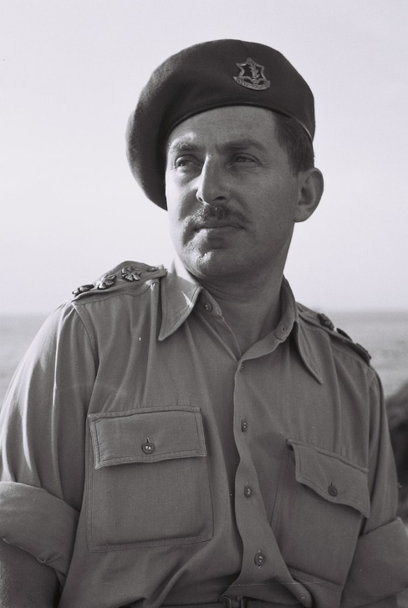
General Chaim Herzog

It was the month of Iyar 5727, the days after the miraculous victory of the Six Day War (June-5-10,1967). The attacking Arab nations had been totally defeated in an incredible few days and parts of our country had been liberated by the Israeli army.
The Western Wall in Jerusalem, the resting place of our matriarch Rachel in Beit Lechem, the Cave of Machpelah in Hebron, the resting place of Yosef in Shechem (Nablus) all these places to which for many years access had been denied to the Jewish people once again were in our possession.
Crowds of jubilant people hugged the stones of the Western Wall and visited the resting place of our Patriarchs and Matriarchs in Hebron and Beit Lechem.
Streams of visitors made their way through the alleys of the old city of Jerusalem on their way to the Western Wall. They were representative of all the many kinds of people that made up the Israeli community: religious, non-religious, veteran immigrants, young and old. The differences of all the varied lifestyles disappeared in the unity of this deeply moving occasion. The children had come home.
Among those making their way through the Muslim section of the old city was General Chaim Herzog, accompanied by his staff, who had been appointed military governor of Jerusalem. They went through the Via Delarosa, which parachutists of the army had entered through the Gate of the Lions, on their way further into the old city and continued to Hagai Street.
All of a sudden an Arab child approached them. Excitedly the child requested from one of the general’s staff to accompany them. From speaking with the young boy, Herzog, an officer in army intelligence, understood that the boy's father was interested in meeting with them.
At first Herzog hesitated, but in the end agreed to meet with the father. The boy took them to one of the houses where they met an elderly Arab man who received them with respect. He opened the door for them and upon entering they stood amazed: before their eyes a big beit midrash (house of Torah study) was revealed. In a small locked side-room, holy books were kept together with furniture.
"I guarded this," the man said with shining eyes. "For nearly 20 years I haven't let anyone touch this place."

Raised Money Throughout Russia
to Establish a Yeshiva in Jerusalem
The story began eighty years earlier. Rabbi Yitzchak Vinograd, a well-known great Torah scholar, emigrated to Israel in 1886 from Pinsk [then] in Russia and settled in Jerusalem. He arrived four years after the aliyah of his father and brother, because he delayed to travel extensively in Russia and Lithuania to raise the funds necessary to establish a yeshiva. When he succeeded to do so, in the Jewish Quarter of the Old City of Jerusalem, he named it "Torat Chaim," after his father, Rabbi Avraham Chaim "Matmid (the Diligent").
The yeshiva was highly praised. Students from all over the Jewish neighborhoods and settlements -- chassidim and non-chassidim, Ashkenazi and Sepharadi -- came to learn there. At its peak there were two hundred students. The study program in the yeshiva was demanding, it began in the morning only ending at midnight.
The yeshiva became known not only in the merit of its high academic level but also because of the pleasant voice and musical abilities of Rabbi Yitzchak. [1] Many came to hear the beautiful way he led the prayers, accompanied by a big choir.

Moved the Yeshiva to a New Location in the Muslim Quarter
When the student body grew, Rabbi Yitzchak bought an empty lot in the Muslim quarter and in 1894 built on it the yeshiva, a project made possible by the donations he had collected. The location was chosen because of its proximity to the Temple Mount. Today the building houses the Ateret Yerushalayim Yeshiva.
Rabbi Yitzchak explained, "When Mashiach will redeem the Jewish people he will no doubt be revealed on the Temple Mount. There he will blow the shofar and gather in the far-flung Jews. The second place he will come to will be here, 'Torat Chaim', the Torah center closest to the Temple Mount."
His dream was that more Jews would follow his example, and would buy property in the Holy City in order to enlarge the Jewish settlement.
Being a Russian citizen still, Rabbi Yitzchak received assistance from the Russian Czarist government. Their representatives in Jerusalem clashed with the Christians, who opposed the building in every way possible. As a result of the establishment of the yeshiva, many Jewish families also moved to the Muslim section, which aggravated the Christians.
The yeshiva also suffered from the hatred of their Arab neighbors. During the pogroms of 1920-1921 in which six Jews were murdered, the yeshiva was set on fire.
A period of quiet followed, but two years later the shamash (caretaker) of the yeshiva was killed and several of the students were injured in an attack by a group of Arabs.

The Yeshiva was Abandoned after
the Fall of the Old City of Jerusalem
The yeshiva then recovered until the pogroms of 1936-1939 a decade later.
At that time an Arab man was hired to guard the yeshiva. His name was Chudat Abdul Ranani. He had been a sergeant in the British army. After his death his brother, Muhammad Abdul Ranani, replaced him. In the following decade, with the fall of Jerusalem in 1948, the yeshiva was abandoned. All were convinced that there was no doubt that the place would be torched and burned to the ground and destroyed by the Arabs, as they did to the "Churva" synagogue and other Jewish holy sites.
And now, 19 years after the last of the students left the hall, here was the yeshiva, whole, exactly as it was on the day it was deserted! There were 3000 undamaged books as well as the bima, the stand of the cantor and the Holy Ark.
A wave of emotion washed through Herzog. His father had merited to hear a Torah class by the founder of the yeshiva decades before, and now he is witness to the yeshiva's redemption.

Why was the Arab Guard So Loyal in Protecting the Yeshiva
Next to him, stunned, stood the soldier to whom to the Arab child had turned. His name was Zerach; he was named after Rabbi Zerach Epstein, the brother-in-law of Rabbi Yitzchak Vinograd, and the last head of Yeshivat "Torat Chaim" before its closing. [2]
"Tell me," said Herzog, turning to Muhmad Abdul Ranani, "during 19 years you have not received your salary for guarding the yeshiva. Why did you continue to do it and so faithfully? How is it you were not afraid to protect Jewish property in the heart of the Muslim quarter?"
"I'll tell you the truth," answered the man, putting his hand on his heart, "I always believed that you would return here. But I want to tell you, that more than me guarding a holy place, the yeshiva guarded and protected me!"
~~~~~~~~~~~~~~
Source: Freely adapted and supplemented by Yerachmiel Tilles from the excellent first-draft translation by C. R. Benami, long-time editorial assistant for AscentofSafed.com, from Sichat HaShavua #1779, based on the report of Ariel Kopler and Chani Glatt. The added details, from Wiki (Hebrew), are the basis for the footnotes and bio notes.
http://www.chabad.org.il/Magazines/Article.asp?ArticleID=13333&CategoryID=2168
Connection: The Yom Yerushalayim (Jerusalem Day) celebration this year starts on Thursday evening, 28 Iyar, May 18.
Biographical notes:
Rabbi Yitzchak Vinograd [5611> 15 Kislev 5673 (1851 - Nov. 1912)] m oved to the Holy Land from Pinsk in 1886. His reputation as a great Talmudic scholar preceded him. Soon thereafter he founded the Torat Chaim Yeshiva in Jerusalem, in the Jewish Quarter of the Old City. In 1894 he financed the construction of a building for the yeshiva in the Muslim Quarter from the funds he had raised in Europe for that purpose before making Aliya. He is the author of the book. “Torat Chaim on Kodeshim.” (Hebrew). One of the suburbs of Jerusalem, “Neve Yaakov,” Is named for him.
Chaim Herzog (1918-1997) was an Irish-born Israeli politician, general, lawyer and author. The son of Ireland's Chief Rabbi Yitzhak HaLevi Herzog, he immigrated to Mandatory Palestine in 1935, where he soon began his long military career, retiring from the IDF in 1962 with the rank of major-general. Between 1975 and 1978 he was Israel's representative to the UN. From 1983 to 1993, he served as President of Israel, a largely ceremonial role. His son Isaac Herzog is the current President of Israel.
Footnotes
[1] Many asked him why he never opted for a career in opera. He said that G-d blessed him with musical talent in order that he would be able to glorify the holy Name of G-d, not his own name.
[2] Another source reports that Rabbi Yitzchak Vinograd was succeeded first by his brother, then his brother-in-law, and finally, his son.

Reprinted from the Parshat Bamidbar 5783 email of KabbalaOnline.org, a project of Ascent of Safed.
The Anti-Semitic Draft Threat of the Polish Government
Against the Lomza Yeshiva

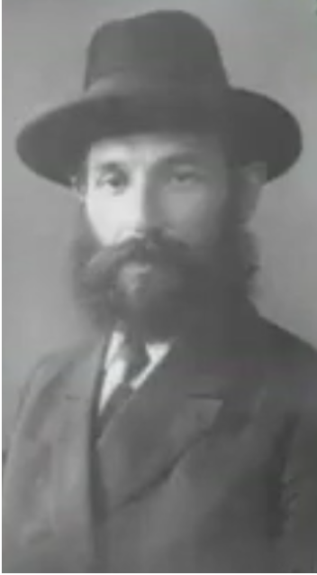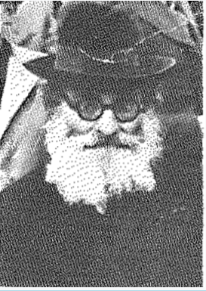
Rabbi Yechiel Mordechai Gordon (left) and Rabbi Moshe Rosenstain of blessed memories
In August 1919, the Polish–Soviet war erupted in the aftermath of World War I. The root causes were twofold: a territorial dispute dating back to Polish–Russian wars in the 17–18th centuries and a clash of ideology due to the Soviet goal of spreading communist rule further west, to Europe.
At that time, both countries had just undergone transition: in 1918, Poland reclaimed independence after 123 years of partitions. In 1917, the October Revolution replaced the liberal, democratic Provisional Government, that had previously displaced the Czar in Russia, with Soviet rule.
Backed by Western powers - primarily France and England - Poland was intent on stopping the spread of Communism beyond Russia’s borders. A general mobilization was put into effect and all able-bodied men were expected to report for military duty.

The Polish Government Refused to
Grant Draft Deferments to Yeshiva Students
While Christian divinity seminaries were granted deferments on religious grounds, the anti-Semitic Polish Government refused to defer students of the Lomza Yeshivah, the only such yeshivah in all Poland at the time.
The Lomza Rosh Yeshivah, R’ Yechiel Mordechai Gordon zt”l went to Warsaw to attempt to intervene. He approached the dean of the Jewish members of the Sejm (the Polish parliament), Dr. Noach Prilucki, an old maskil. Prilucki would only offer deferment to the yeshivah students if the yeshivah would incorporate some secular studies in the curriculum.
“A decision such as this,” replied R’ Yechiel Mordechai, “I cannot take upon myself. I must seek advice.”
“Really? Even though in the meantime your boys are being drafted and sent to the battlefield?” asked Dr. Prilucki.
“Yes, even at that price,” replied the Rosh Yeshivah. “I am required to consult with daas Torah on such a matter.”

Foreign Elements Cannot Be Mixed in Yeshiva Studies
Back in his hotel room, he fell asleep and dreamed of the posuk: “All leaven or honey you shall not burn as an offering to Hashem” (Vayikrah 2-11). Foreign elements - neither sour nor sweet - can ever be mixed before Hashem. The message was clear, but R’ Yechiel Mordechai would not rely on a dream to close a yeshivah.
Under normal circumstances, the he would have consulted with Gedolei Hador all over Poland and Lithuania, however, the war made communicating with the Chofetz Chaim zt”l in Radin, or R’ Chaim Ozer Grodzenski zt”l in Vilna, all but impossible, so R’ Yechiel Mordechai returned to Lomza to seek the advice of the saintly Mashgiach, R’ Moshe Rosenstain zt”l.
After much consideration, the Mashgiach responded. “It is clear that Hakadosh Baruch Hu requires mesiras nefesh from us for Torah. We are not obligated to display mesiras nefesh for secular studies, however. We cannot mix the two - kodesh and chol - the sacred and the profane cannot dwell together.”
“But boys are being drafted,” protested the Rosh Yeshivah.
The Mashgiach was a firm believer in the Vilna Gaon’s “Gorel,” a lottery that indicated a decision through selection of a posuk. The Gorel HaGra was done and a quotation from a posuk was selected. It turned out to be a Divine command to Moshe, in Parshas Bamidbar, which read: “From twenty years old and upward, all that are able to go forth to war in Israel: you shall number them by their hosts, you and Aharon.”

Contacted the Chairmn of the Local Draft Board
His own name was Moshe, so with a student by the name of Aaron (Zlotowitz), he set out to solve their dilemma, in accordance with the command in the posuk. They established contact with the chairman of the local draft board. He agreed to free all the Bnei Torah for a set amount of American dollars (he refused to accept Polish Zloty).
It was illegal to possess dollars, but these were his terms. The Mashgiach justified this “illegal” approach, for Bnei Torah should have been deferred as were Christian divinity students, except for Polish anti-Semitism that denied them their legal rights. If Poland was anti-Semitic, the army was tenfold worse. Honoring Shabbos and kashrus here was practically impossible.
Hence, Bnei Torah from all yeshivos threatened by military conscription arrived in Lomza finding a place to learn, with room and board, thus establishing residency there. With the necessary funds in American currency, they were safe. For the next twenty years, as long as Poland was independent, Lomza served as a haven for such Bnei Torah.

Reprinted from the Parshas Bamidbar 5783 edition of Rabbi Dovid Hoffman’s Torah Tavlin parsha sheet.

The Redemption of the Foreign Coin Collection

I am a bachur with a weakness for various foreign coins, especially when it comes to collectibles. I went to my grandparents for Shabbos and on Friday close to Shabbos, I talked to my grandfather about the different coins I saw and found.
When my grandfather saw the glint in my eyes, he told me that he had a bag of coins from his parents that was supposed to be somewhere in the storage room. Soon after Havdalah, I hurried to the storage room and started looking for the collection that my grandfather was talking about that he received from his father… after turning over the whole storage room, I found the bag.
It was a heavy bag that I could hardly lift. I brought the bag in the house and started going through its contents. There were collectors’ coins in special holders and other strange coins. My heart rate increased by the minute, when I told my grandfather that this was a real treasure. Saba began to understand that there was indeed some value to this bag and decided to take the collection to a coin dealer in the hope of receiving a few thousand shekels in return.
The dealer looked and offered 40,000 shekels in return. Saba realized that there was real value here and went from dealer to dealer until he received an offer of 130,000 shekels that he realized was the best offer he would receive for the collection.
The joy of my grandparents was very great since they wanted to write a Sefer Torah for the elevation of their parents’ neshamos but could only save a small amount. They did not know how they would come up with the rest of the money, and especially when there were additional expenses of a silver crown, a seudah, and hachnasas Sefer Torah.
Now Hashem took pity on them and thanks to my curiosity they discovered the treasure. When I asked how they did not notice it until now, they said that at the time of the death they were dealing with a lot of details, and it was something they simply put in the storage room without thinking about it, or thinking too much trouble was involved with it.
There is a time and a place for everything under heaven and the salvation was already prepared beforehand. As for me, I understood that this yen for collecting coins I inherited from my great-grandfather.

Reprinted from the Parshas Bamidbar 5783 edition of Tiv Hakehila.

The Sincere Mazel Tov
to a Simple Handyman

There was a simple Yid who worked as the handyman in the yeshivah of R’ Moshe Klier zt”l in Teveria. One day, the handyman’s son became engaged. Although it was a very joyous occasion for himself and his family, he didn’t expect that anyone at the yeshivah would be particularly interested in his personal news. He happened to mention his simcha to the Rosh Yeshivah, R’ Moshe, in a passing conversation and very nonchalantly.

The Rosh Yeshiva Went to the Bais
Medrash with a Purpose in Mind
The Rosh Yeshivah smiled warmly and gave him congratulations, wishing him a hearty Mazel Tov and beracha. Then he continued on to the Bais Medrash. But really, R’ Moshe wasn’t finished just yet. He understood how much this joyous occasion meant to anyone, and so much more to this simple handyman who wasn’t exactly a social bird.
He probably didn’t have too many friends and as many congratulating remarks as possible would no doubt go along way with the simply man. R’ Moshe went to the entrance of the yeshivah and stopped each and every boy before entering the building, informing him that the handyman’s son had become a chosson and how much it would mean to him if he was congratulated on this occasion.
The boys understood. Every single student approached the handyman and wished him a warm and hearty Mazel Tov. The handyman glowed with joy. “You illuminated my life!” he exclaimed to the Rosh Yeshivah.

Every Yid Needs to be Uplifted
Parshas Bamidbar is primarily about counting. Each and every Yid is counted and accounted for, as each and every Yid is special in his and her own unique way. Taking interest in a fellow Jew means realizing that from him too, there is what to learn and what to glean inspiration. For this reason, the Torah begins the parsha by saying “Lift up the head of every individual in Klal Yisroel,” for every Yid who is accounted for is uplifted and elevated.

Reprinted from the Parshas Bamidbar 5783 edition of Rabbi Dovid Hoffman’s Torah Tavlin parsha sheet.

My Child

THE ROSH YESHIVAH OF UNSDORF, Rav Shmuel Rosenberg, once called a specialist from Budapest to treat a sick bachur. When he came to treat the bachur, the doctor could not help but notice the loyalty and love that existed between the bachurim who were present.
“I studied many years in university,” the doctor said to the Rov, “and I never saw such unity and mutual caring among the students there. What is the difference with your students?”
“I love all my talmidim as if they are my own children,” the Rosh Yeshivah answered, “and therefore they consider each other's brothers.”

Trust in Hashem

RAV MOSHE AHRON AUERBACH ל"זצ after working for a Jewish company for quite some time he was summoned to a meeting with the CEO’s of the company. Since R’ Auerbach was already getting on in his years, he knew good and well what this meeting meant; a cut in his salary.
R’ Auerbach was a man of unbelievable Bitachon in Hashem. The day of the meeting arrived and R’ Auerbach approached the office where his bosses were waiting. R’ Auerbach walked into the room and sat down.
One of the CEO’s spoke up and said, “R’ Auerbach, do you have anything to say before we tell you what we have to say?”
R’ Auerbach answered, “Yes." R’Auerbach pulled out a candy from his pocket took off the wrapper and recited the shehakol blessing. R’ Auerbach was trying to tell his boss that he fears nothing. They are not the ones giving him his parnassa. The only One who really makes the decision is Hashem Himself – ''בדברו!

Reprinted from the Parshas Bamidbar 5783 edition of Etz Hachayim.

The Dybbuk (Evil Spirit)
By Rabbi Mordechai Levin

There are numerous reliable stories about various dybbuks (an evil spirit/ neshama forced to wander due to a sin that he/she committed while alive, that enters and possesses the body of a living person).
Rav Aharon Leib Shteinman, Z”TL, writes of a few such stories that he personally heard from authentic sources. At the time of Reb Chaim Volozhin there was a dybbuk who said that he was the first person to throw a rock at Zechariah Hanavi (prophet), who was killed by stoning for rebuking the Jewish people.
Reb Chaim commented then how grave that sin was, for this poor soul had been wandering for over 2,000 years and still had not finished paying for his transgression.
Rav Shteinman said that when he was young, living in the city of Kaminetz, he met an elderly retired rebbe who related that in 1859, a dybbuk entered the body of a young boy. The parents searched for a Tzaddik to remove the dybbuk, and came to Kaminetz.
The Rav of Kaminetz for 38 years was Reb Avrohom Segal, a great Kabbalist. He gathered all the adults of Kaminetz into the cemetery, and there, he was able to pull out the dybbuk from the boy’s body. When asked what he had done to be so punished, the dybbuk replied that he had intentionally taken a siddur into the bathroom! The incident served as a great impetus for the people of Kaminetz to strengthen their adherence to Mitzvos.
Rav Shteinman said that the last dybbuk appeared in the days of the Chofetz Chaim, for until then, righteous people were shown clear signs from Heaven. Afterwards, even those signs became hidden.

Reprinted from the Parshas Bamidbar 5783 email of Torah Sweets.

